Gabriella Solano

Research Proposal

University of Florida

Introduction
Data driven instruction. In my three years teaching ELA in a Title I dual language elementary magnet program housed in a neighborhood school I have heard these words more times than I can count. The first time I saw this phrase was at the top of a meeting agenda. As a new teacher fresh out of graduate school I assumed data encompassed information retrieved from the multiple and varied assessments I was taught to use. I came with my arms full of student notebooks, work samples, and observations. To my surprise I was only asked to take out a score report from a standardized baseline assessment of reading and writing skills students took their first week.
These numbers were suffice to fill bulletin boards that were divided in thirds. The top was for students in top percentile, known as ‘high flyers.’ The middle for average scores, known as ‘bubble students.’ The bottom was for lowest scores, known simply as “low.” I was handed green index cards to write and post high flyer names and scores, yellow for bubble kids, and red for the “low babies,” as administrators called them. As I wrote I noticed last names such as Smith and Williamson dominated the green while Barrios and Barreras overwhelmed the red. This disparity did not match the student progress I was tracking through student centered discussions, writing projects, and teacher student conferences nor did it acknowledge the funds of knowledge each student contributed to the learning environment.
Furthermore, the content of the board contradicted the presentation I was given the week before in Dual Language training promising the program promoted biliteracy and cross cutlutral connections. The board also did not match the Power Point celebrating new student centered curriculum I sat through a week before that and did not align with everything I learned about researched based best practices in graduate school.
Looking at the board complete with each student identified by color and score led to frustration and confusion. As a Latina I was personally affected by seeing almost all of my latino/a students in the red and as a passionate new teacher I was confused by this visual paradox between who the students were and how they were represented. After three years filling out the same board the frustration remains, but the confusion is replaced with an understanding of ‘data driven instruction’ as both a mandate and a promise. A mandate to use test data to make teaching decisions and a promise that doing so is best for the school and students.
I share this anecdote to exemplify the problem of practice I find most pressing; the lack of formative assessment and its effect on English language learner personal and academic identity in language arts setting. My diverse teaching context places standardized summative assessment data at top priority, which I find counterintuitive and damaging. Exclusive use of standardized data reduces students and teachers to a score and implies that the right to learn must be earned through test performance (Barrier-Ferreira, 2008). Despite research supporting use of formative assessment as tool for learning and building student confidence (Black, 2018) teachers are directed to rely on standardized data to drive instruction (Barrenechea, 2018).
My first three years in the classes provided wealth of anecdotal evidence that the emphasis on standardized assessment further isolates the already marginalized English Language learners, widens achievement gap, and perpetuates deficit ideology. Ethnographic research (Pandya, 2011), critical analysis of standardized test items (Winter, Kopriva, & Chen, Emick, 2006), and nationwide surveys assessing impact of assessment on minority students (Lomax, West, Harmon, Viator, &Maduas, 1995) support these classroom noticings.
My initial observations led me to wonder about potential connection between standardized data driven instruction and the widening achievement gap between English language learners and the native English speakers they share a classroom with in dual language setting. While I see a clear link, the conclusions I draw from my experiences and preliminary research are a product of my positionality as a young Latina educator and therefore I am called to research with intent to discover what is possible instead of prove what is right. I ask, how might implementation of formative assessment in Dual Language writing classroom impact English Language Learner ability to use language as a tool to connect with teachers, self-assess, and advocate for themselves as equal members of the classroom?
Literature review
To unpack this question I asked a series of questions about formative assessment and its potential uses. I purposely focused my search on formative assessment rather then ELL instruction to better understand formative assessment and determine if there is a potential link between this kind of assessment and ELL empowerment. The need to clarify the definition of formative assessment is where my exploration began. From there I asked, what does formative assessment look like in the classroom? Why use it? What is stopping us from using it? And finally, where is the research on how this affects minoritized students?
What is The Difference Between Summative and Formative Assessment?
While perspectives on formative assessment are varied, the reoccurring idea is that formative assessments are an assessment for learning. Dixson and Worrell (2016) present conceptual explanation that summative assessments measure learning outcomes and use results to rate and/or promote students while a formative assessment is qualitative, informal, ongoing, and seeks to improve teaching and learning. Paul Black (2001) takes these explanations further and characterizes assessments as dreams for education. He analyzes assessment through its history and uncoveres how the origins of summative assessment are rooted in the ‘dream’ of finding a way to separate those that are capable of learning from the rest. He found formative assessment emerged later in education history as a dream for reform, its major aim being to improve teaching and learning by offering multiple, varied, and ongoing opportunities to reflect and measure progress over a product (Black, 2001).
What Black (2001) finds about the goal of summative assessments to separate those who can and can not learn points to the inequity inherent in the exclusive use of this assessment form. However, the literature also argues that the distinct goals of these two assessment categories are potentially complementary depending on how educators implement them (Dixson and Worrel, 2016).
What Does Formative Assessment Look Like in the Classroom?
There is not one standard technique for formative assessment. The common thread among different techniques is not so much protocol, but principle. Black &William (as cited in Dixson and Worrell, 2016) explain that formative assessment techniques are “activities…that provide information to be used as feedback to modify teaching and learning activities…it encompasses a whole host of tools that…help students learn more effectively” (p.154).
Volante and Beckett (2011) offer clarity on what precisely that can look like by detailing specific formative assessment tools, such as “a student journal reflection, self-assessment of a performance, or submission for a draft of a final assignment” (Volante &Beckett, 2011, p 240). Their research framed with assessment for learning construct conducted and analyzed interviews with a sample of twenty elementary teachers about formative assessment techniques. Overall the way teachers used these techniques varied which highlights the many ways formative assessment can manifest in a given classroom (Volante & Beckett, 2011). The successes and challenges teachers had did not correlate with a specific subject matter or grade level suggesting that implementing formative assessment is a challenge all sects of education face and therefore what formative assessment looks like in the classroom is not fixed or universal.

Why Use It?
The research advocating formative assessment either highlights the success of a specific technique in a particular context or by suggests conceptual implications of formative assessment on teacher and student attitude toward learning and achievement.
Bakula (2010) found, through action research using formative assessment with her middle school science students, that students were more aware of their understanding and improved their performance in summative exams. Similarly,Anderson and Palm (2017) conducted a quantitative study with Swedish math teachers that tracked student scores on math tests after implementing formative assessments in their classes and found students performed better on summative tests than previous years (Anderson and Palm, 2017). Contrarily, Meusen-Beekman, Joosten-ten Brinke, and Boshizen(2016) focused on behavior. They conducted a randomized control study with 31 sixth grade classes from seventeen different schools in the Netherlands. They used a questionnaire to determine how students self-regulated learning before and after implementing peer and self assessment in writing. They found formative assessment effective in improving self-regulation as well as motivation (Meusen-Beekman et al., 2016). These findings are not universal or directly applicable due to the small and specific subject groups and geographic diversity of the research. However, this diversity of settings and participants also suggests that the overall potential benefits of formative assessment are varied and applicable in multiple settings.
Other research focuses less on the current use of formative assessment and explores its potential future uses. Black (2018) in a separate study from his historical look at assessment, describes a conceptual idea about how formative assessment measures can potentially impact student relationship to learning, achievement, and the purpose of school(Black, 2018).

What’s Stopping Us From Using Formative Assessment?
Research has identified a few factors hindering implementation of sustainable and effective formative assessment. Both Volante and Beckett (2011) and Black (2001) emphasize teacher training and mentality as a significant factor impeding the implementation of formative assessment. The ethnographic interviews with teachers conducted by Sezen-Barrie and Kelly (2017) furthers this discussion by illuminating how many teachers feel administration ignores their perspectives and challenges with implementing informal assessments.
Sherman Dorn (2010), using historical, cultural, and organizational frameworks, shifts focus to current political factors. Consistent with this focus, Black (2001) explicates summative assessment receives more political attention and support than formative assessment because of its association with the political agenda of socializing students for the workforce. Dorn (2010) echoes and supports this notion by reflection on longstanding loyalty to high stakes testing in schools and the idea that without these tests we will lose rigor and accountability. These findings that expose the education system favors summative assessment due to its efficiency in conserving the current system of hierarchies reinforce my notion that formative assessment could potentially serve as a tool for reform.
Where is the research on how this affects minoritized students?
Most of the research that analyzes formative assessments effects on English language learners comes from science education and explores ways to use formative assessment to improve summative scores. Keely (2014) offers multiple strategies to link culturally responsive teaching and assessment. Lyon (2017) examines how teachers implement these strategies through observation of middle school teachers. Lingying, T (2016) shifts focus and asks how formative assessments can alleviate oral English speaking anxiety faced by Chinese English language learners. Through survey of student anxiety levels, she found the students reported lower levels of anxiety after receiving formative assessment. Apart from this study, most current research places emphasis on impact of formative assessment on grades and test scores and does not address its potential impact on culturally responsive teaching and fostering student self-advocacy.
When looking at these research studies holistically what is most salient is that there are an abundance of formative assessment instruments and a myriad of potential uses for them, however, among this abundance, nondominant populations and teaching settings are missing. The literature delves deep into how we use assessment, why we use it, and how it impacts students and teachers. However, it does not focus on the place formative assessment could have in a dual language setting, the effect it might have on ELL students in ELA classrooms, the way it might change teacher and student experience and relationship.
These are the questions the literature does not ask and require exploring with a sense of urgency. The education field requires an understanding of the current and potential role of formative assessment in the margins. Based on the voids I have found in assessment use, understanding, and impact as related to English Language Learners both in my teaching context and in the literature, I find it imperative to fill this knowledge gap by making non dominant populations the dominant participants.
Theoretical frameworks
I am approaching this problem of practice as flaw in teaching methods that is rooted in systematic inequality. For this reason I am organizing my research around two frame works; cultural historical activity theory (CHAT) and critical pedagogy. The former provides a lens with which to examine the issue of practice and the later addresses the source of this issue and its implications.
Cultural historical activity theory “has developed from two broad strands of work: Russian cultural psychology which started with Vygotsky and North American and European interactionist psychology. They have been brought together by a concern about the separation of mind and world (Edwards, 2005, p. 2).” The concern for the separation of mind and world is the primary tenet of this framework that will drive my research. Secondly, its constructivist approach to instruction that connects student understandings derived from personal and cultural experiences to new learning instead of replacing what on knows with what one needs to know (Edwards, 2005) will also anchor my research. I will build upon this research emphasizing how mind and society interact and inform each other. This will serve as frame for how I link the exclusive use of summative data and student development, relationship to school, and belief that identify, ability, and worth is tied to a quantitative score.
The second framework that is essential to answer my research question, critical pedagogy, is “an approach to language teaching and learning which, according to Kincheloe (2005), is concerned with transforming relations of power which are oppressive and which lead to the oppression of people. It tries to humanize and empower learners. It is most associated with the Brazilian educator and activist Paulo Freire using the principals of critical theory of the Frankfurt school as its main source (Aliakbair & Faraji, 2011, p.77).” The principles of this framework that will be central to my research are the call to for critical look at the inherent injustices in our practice and the aim to transform power dynamics of inequitable education system. Using these tenets I will take research beyond reflection on practice and pose objections to the questions that are currently central to educator reflections such as how a child earned a score? And how to get them to earn a better one?
These two frameworks in conjunction will allow me to fill gap in research that exists by examining the issue of assessment as one that is linked to issues of inequity, childhood development, and language instruction. CHAT, framing how I examine assessment connection to latter two elements and critical pedagogy grounding this examination in aim to expose and transgress hegemonic model driving education.
Humanizing methodology
The frameworks I am employing necessitate a critical look at the issue that goes beyond replacing standardized data driven instruction with formative data. I seek to explore sustainable systemic changes and amplify minoritized voices by including them as research designers. These voices I will work with are English language learners and teachers who refuse to comply with the notion that summative scores are enough to understand these learners.
To do so I am employing humanizing methodology of social design research. In social design work, equity and learning are brought together in designing for consequential learning and transformational change (Gutiérrez & Jurow, 2016). This immediate and practical aim of intervening in conjunction with broader aim of restructuring how we intervene will ground my study and ensure it does not further perpetuate imbalance of power.
I will work with students and teachers to address assessment issues in writing. Students and teachers consistently state writing is the greatest area of struggle. Research highlights it as a tool for students to make making meaning out of what they see, read, and hear which results in a more complete understanding of the world, oneself, and how to self advocate and express oneself (Graham, Gillespie, McKeown 2012). For both these immediate needs cited by teachers and students as well as the research on potentially deeper and sustainable effects of improved writing assessment and instruction I find it critical to focus research on writing assessment for English Language Learners in a Dual Language setting.

Methods
Participants and setting
Participants will be three fourth grade dual language teachers and their students from three different schools. Each are ELA classes (English language reading and writing) in Title 1 dual language programs with student populations that are about half English language learners and half native English speakers (for exact demographics see Appendix A). The research will take place in each classroom as well as in common spaces where teachers can meet after school.
Data Collection
Because I am excavating this issue with cultural historical activity theory and critical pedagogy I will use inquiry groups, surveys, and interviews that require participants to think critically, utilize their personal and cultural experiences to build new understandings, and experiment with co-created formative writing assessment technique. These methods have multiple objectives (a) reveal student and teacher perspectives on assessment (b) evaluate effect the formative assessment technique created and piloted by teachers has on teachers and ELL students (c) gain insight into how teachers and students feel about participating in research design (d) expose what issues and needs remain (e) provide understanding of possible ways to address those needs.
Inquiry groups I will facilitate, record, and reflect on inquiry groups with colleagues. The sessions will begin looking broadly at issue of assessment and grow progressively deeper and focused on effect of assessment on English language learner. Groups will meet a total of five times. The sessions will be organized as follows:

- I will facilitate open-ended discussion of assessment issue. Next, I will distribute literature focused on assessment issues and English language learner instruction teachers will read independently before following session
- I will facilitate discussion of literature and group will craft survey for students about assessment. for literature and guided questions see Appendix B).
- Group will reflect on survey data and create new formative assessment technique tailored to the needs expressed by ELL students in survey and interviews.
- Group will discuss mid-way progress with technique.
- Group will reflect on post assessment student survey and interview data.

Survey and interviews In inquiry groups teachers will formulate surveys about writing assessment using notes from preliminary open ended discussion, discussion of literature, and guidelines from “Youth Participatory Action Research Hub Berkely” (YPARHubBerkely, 2015). Survey process will go as follows:

- Teachers will administer survey to students and follow up with recorded interviews with students about their responses.
- Interviews and surveys will be discussed in inquiry groups. Data will be used to collaborate on new formative assessment strategy that addresses the needs the students express.
- After implementing new technique teachers will administer a post assessment strategy survey followed by recorded interviews.
- Inquiry groups will discuss data and how the assessment affected students.

Journal reflections. Teachers will write journal reflections on their experience with inquiry groups, using new assessment strategy, and ideas students express in interviews. As the inquiry group facilitator, my reflection will include my experience guiding discussions. (For guided reflection questions see Appendix C)

References
Aliakbari, M., & Faraji, E. (2011). Basic principles of critical pedagogy. IPEDR, 17, 77-83.

Anderson, C., & Palm, T. (2017). The impact of formative assessment on student achievement: A study of the effects of changes to classroom practice after a comprehensive professional development program. Learning & Instruction, 4992-102. doi:10.1016/j.learninstruc.2016.12.006

Bakula, N. (2010). The benefits of formative assessments for teaching and learning. Science Scope, 34(1), 37-43.
Barrier-Ferreira, J. (2008). Producing Commodities or Educating Children? Nurturing the Personal Growth of Students in the Face of Standardized Testing. Clearing House, 81(3), 138-140.
Black, P. (2018). Helping students to become capable learners. European Journal of Education, 53(2), 144-159. doi:10.1080/09695940120033261

Black, P. (2001). Dreams, strategies and systems: portraits of assessment past, present and future. Assessment in Education: Principles, Policy & Practice, 8(1), 65-85. doi:10.1080/09695940120033261

Dixson, D. D., & Worrell, F. C. (2016). Formative and summative assessment in the classroom. Theory Into Practice, 55(2), 153-159. doi:10.1080/00405841.2016.1148989

Dorn, S. (2010). The political dilemmas of formative assessment. Exceptional Children, 76(3), 325-337.
Edwards, A. (2015). Cultural historical activity theory: A relational turn. Teaching and Learning Research Program. Retrieved from http://www.leeds.ac.uk/educol/documents/156916.htm

Graham, S. s., Gillespie, A., & McKeown, D. (2013). Writing: importance, development, and instruction. Reading & Writing, 26(1), 1-15.

Keeley, P.(2014). Assessment for all. Science & Children, 51(5), 32-35.

Lingying, T. (2016). Formative assessment in oral english classroom and alleviation of speaking
apprehension. Theory & Practice in Language Studies, 6(4), 751-756.

Lyon, E. G. (2017). Exploring secondary science teachers’ enactment of assessment practices to reflect responsive science teaching for english learners. Journal of Science Teacher Education, 28(8), 674-698. doi:10.1080/1046560X.2017.1401415

Meusen-Beekman, K. K., Joosten-ten Brinke, D., & Boshuizen, H. P. (2016). Effects of formative assessments to develop self-regulation among sixth grade students: Results from a randomized controlled intervention. Studies In Educational Evaluation, 51126-136.

Pandya, J. Z. (2011). Overtested: How high-stakes accountability fails english eanguage learners. New York, NY: Teachers College Press.

Richard G., L., Mary Maxwell, W., Maryellen C., H., Katherine A., V., & George F., M. (1995). The Impact of Mandated Standardized Testing on Minority Students. The Journal Of Negro Education, (2), 171.
Sezen-Barrie, A., & Kelly, G. J. (2017). From the teacher’s eyes: facilitating teachers noticings on informal formative assessments (IFAs) and exploring the challenges to effective implementation. International Journal of Science Education, 39(2), 181-212. doi:10.1080/09500693.2016.1274921
Volante, L., & Beckett, D. (2011). Formative assessment and the contemporary classroom: Synergies and tensions between research and practice. Canadian Journal of Education, 34(2), 239-255.
Winter, P. C., Kopriva, R. J., & Chen, C. (2006). Exploring individual and item factors that affect assessment validity for diverse learners: Results from a large-scale cognitive lab.
Learning & Individual Differences, 16(4), 267-276.

Appendix A
Demographic Information for School Sites From District Data Reports 2017-2018
School Site 1: Beauclerc Elementary
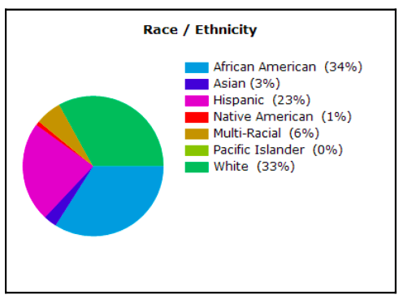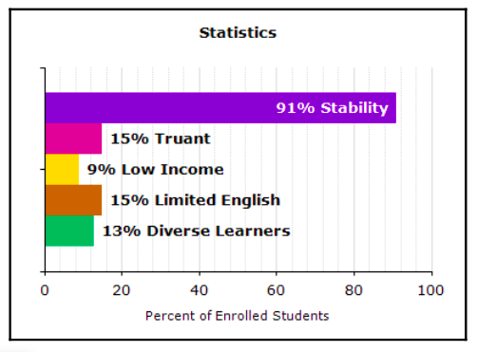
School Site 2: West Riverside Elementary
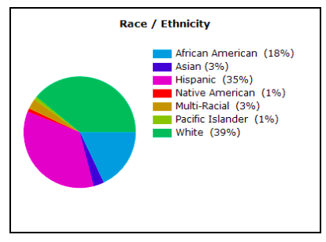
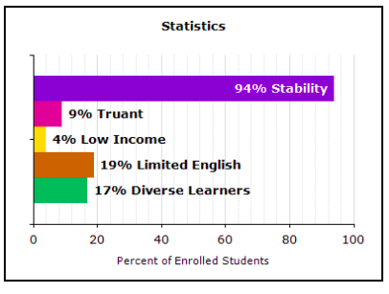
School Site 3: San Jose Elementary
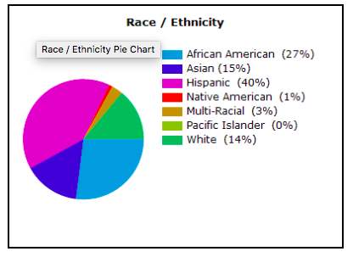
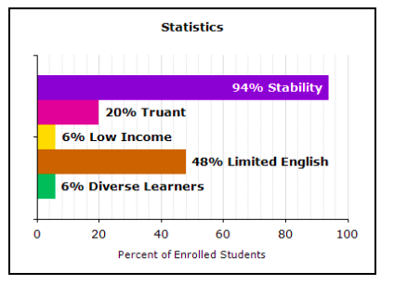
Appendix B
Inquiry Group open-ended discussion questions
- How would you explain the purpose of assessment?
- What do you think is meant by data driven instruction?
- How have you used assessment in your classroom?
- How do your students respond to assessment?
- What are the greatest challenges you have faced with assessment?
- What do you think the cause(s) of these challenges are?

Literature and corresponding discussion questions
1. Barrier-Ferreira, J. (2008). Producing Commodities or Educating Children? Nurturing the Personal Growth of Students in the Face of Standardized Testing. Clearing House, 81(3), 138-140.
Standardized testing is a reality with which all educators must contend. Although the laws enforcing such assessments do so under the premise that students will thereby be assured an equal opportunity for academic success, they overlook a critical point—students are human beings with needs that reach beyond what is measured on a test. In this article, the author examines the impact of standardized testing on the educator’s ability to adequately address these needs and questions whether the focus of education has turned to treating children as commodities rather than helping them to develop not only their intellect but also their emotional and social selves.

Do you connect with the argument the author makes about standardized testing hindering ability to meet students emotional and social needs? How so?

How might your teaching approach be different if you did not have to consider standardized testing?

Does assessment data factor into how effective you feel you are as a teacher? If so, how much?

2. Hernandez, R., Menchaca, V., & Huerta, J. (2011). A study of the relationship between students' anxiety and test performance on state-mandated assessments. US-China Education Review, 579-585.
This study examined whether relationships exist between Hispanic fourth-grade students’ anxiety and test performance on a state-mandated writing assessment. Quantitative methodologies were employed by using test performance and survey data from 291 participants. While no significantly direct relationship exists between students’ levels of anxiety and their performance on the TAKS (Texas Assessment of Knowledge and Skills) writing assessment, other findings indicate that greater time spent on the writing assessment, result in higher scores as well as greater levels of anxiety.
How do the results of the study compare with what you see in the classroom?

Do you find your ELL students struggle more with standardized assessment? If so, why do you think that is?

3. McCarthey, S. J., & García, G. E. (2005). English language learners' writing practices and Attitudes. Written Communication, 22(1), 36.

This study of English language learners, six Mandarin-speaking and five Spanish-speaking elementary students, revealed that students engaged in a variety of writing practices at home and school. A continuum of attitudes,from positive to negative, characterized students' attitudes toward writing in English and their native languages. Students' writing practices and attitudes toward writing were influenced by home backgrounds and classroom contexts. Home background influences included parents' educational backgrounds and income levels, plans for staying in the United States, support for writing at home, and cultural expectations. School and classroom factors included frequency and quality of opportunities for writing and teachers' expectations for writing tasks. Implications of the study include the necessity to provide multiple opportunities for students to write for purposeful audiences in their native language as well as in English.
What are some news understandings about your ELL students you gain from this article?

What are some ideas you have to meet needs of ELL students in writing?

4. Lee, I. (2016). Putting Students at the Centre of Classroom L2 Writing Assessment. Canadian Modern Language Review, 72(2), 258-280.

In many educational contexts, L2 writing assessment tends to emphasize its summative functions (i.e., assessment of learning – AoL) more than its formative potential (i.e., assessment for – AfL). While the teacher plays a dominant role in AoL, central to AfL is the role of the students, along- side that of the teacher and peers. A student-centred approach to L2 writing assessment involves learners actively in setting goals, monitoring their prog- ress, and deciding how to address the gaps in their learning. Such a focus, also referred to as assessment as learning (AaL), puts students at the centre of classroom assessment. In the L2 writing literature, however, descriptions and explanations about how AaL can be implemented in the writing classroom are scant. This article attempts to provide a clear understanding of AaL and how a student-centred approach to classroom assessment can be applied in the L2 writing classroom, thus contributing new knowledge to the existing literature on classroom L2 writing assessment.
- What is your understanding of the difference between assessment for learning, assessment of learning, and assessment as learning?

- Do any of your lessons resemble the strategies from the article?

- Do you see potential benefits in using these strategies? Do you find any potential challenges? If so, what are they?

- How would you tailor the recommendations in this article for your students?

Appendix C
Journal reflection questions for participants
- In our first session we discussed the question “how would you explain the purpose of assessment?” has your answer to this question changed? If so how has it changed and why?
- What did you find most beneficial about the new strategy? What did you find most challenging?
- Based on student responses, what would you modify about this strategy if you were to implement it again?
- How would you describe your experience collaborating with teachers? What effect, if any, did it have on your teaching?

Journal reflection questions for myself

- In our first session we discussed the question “how would you explain the purpose of assessment?” do you find the answers teachers initially had have changed? If so how has it changed and why?
- What did you find most beneficial about the new strategy? What did you find most challenging?
- Based on student responses, what would you modify about this strategy if you were to implement it again?
- How would you describe your experience facilitating inquiry group with teachers? What effect, if any, did it have on your teaching?

